Appendix 4

Ethnicity Pay Gap Report
As of 31 March 2025

Introduction
This report presents the ethnicity pay gap analysis for Tamworth Borough Council, based on data as of 31 March 2025. The methodology used aligns with national guidance for gender pay gap reporting. While disability pay gap reporting is currently voluntary, an increasing number of progressive councils are adopting it to promote transparency and inclusion.

Workforce ethnicity profile
90.5%of our employees are White, 3.4% are Asian, 2.9% are Black and 1.6% are mixed ethnicity, 1.57% prefer not to say. Our community demographics, taken from the last census are 95.8% are White, 1.4% are Asian, 0.6% are Black and 1.9% are of mixed ethnicity. Therefore, the council is more diverse than the community it serves.
 | Head Count | Percentage
Asian or Asian British | 13 | 3.4%
Asian or Asian British – any other Asian background | 6
Asian or Asian British - Bangladeshi | 1
Asian or Asian British - Chinese | 2
Asian or Asian British - Indian | 3
Asian or Asian British - Pakistani | 1
Black, African or Black | 11 | 2.9%
Black, African or Black Caribbean - African | 2
Black, African or Black Caribbean – Any other black British or Caribbean | 4
Black, African or Black Caribbean - Caribbean | 5
Mixed or multiple ethnic groups | 6 | 1.6%
Mixed or multiple ethnic groups – White and Asian | 4
Mixed or multiple ethnic groups – White and Black Caribbean | 2
White | 344 | 90.5%
White – English, Scottish Northern Irish or British | 333
White – Irish | 3
White – any other white background | 8
Not recorded | 6 | 1.57%

Key pay gap metrics
It is important to note that when reporting ethnicity pay gap data for small groups, such as when only small numbers belong to an ethnic minority group, there are significant limitations. Firstly, the small sample size can lead to statistical volatility, where the presence of a single high or low earner can disproportionately affect the mean pay gap. Secondly, privacy and confidentiality concerns arise, as individuals may be more easily identifiable.
To mitigate these risks, the data has been aggregated into broader ethnic categories. This ensures responsible reporting while maintaining transparency and protecting individual privacy.

Ethnicity pay gap
Our mean ethnicity pay gap is -8.76%, our median ethnicity pay gap is -1.01%
This means that ethnic minority employees earn more on average than white employees which is a rare and positive outcome in the public sector.

 | Mean hourly rate | Median hourly rate
Ethnic minority group | £19.80 | £16.94
White | £18.20 | £16.77
Average | £18.32 | £16.80
Difference | £1.60 | 0.17p
Hourly rate percentage | -8.76% | -1.01%

Breakdown by quartile
 | White | Ethnic minority
Top Quartile | 91.21% | 8.79%
Upper Middle Quartile | 93.41% | 6.59%
Lower Middle Quartile | 94.62% | 5.38%
Lower Quartile | 92.55% | 7.45%

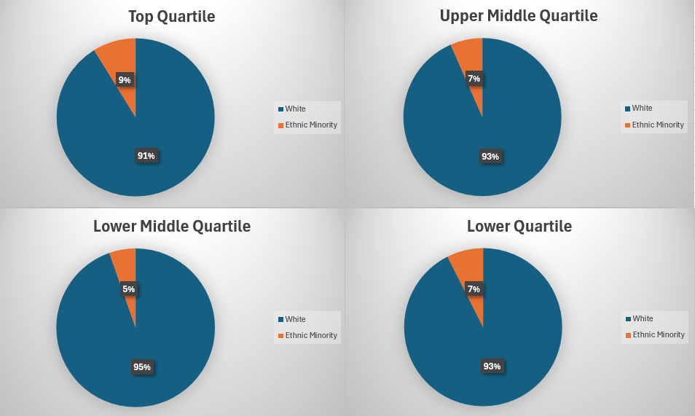
Benchmarking
As ethnicity pay gap reporting is not mandatory, benchmarking becomes more difficult.
Birmingham City Council –median ethnicity pay gap is 3.8% in favour of white employees.
Mean ethnicity pay gap 5.3%
Wolverhampton City Council – median ethnicity pay gap is 3.7% in favour of white employees.
West Midlands Police – median ethnicity pay gap is 5.3% in favour of white employees
Reading Borough Council - median ethnicity pay gap is 0.68% in favour of white employees.
Regulator of Social Housing – mean ethnicity pay gap 7.6% (in favour of white employees) Median – 8.9%
The latest data from the ONS reported a mean pay gap of 5.7%

Conclusion
The negative pay gap is influenced by a small number of high earning ethnic minority employees which can skew averages. Small sample sizes increase volatility and reduces reliability.
Nonetheless, Tamworth Borough Council remains committed to fostering a workplace that is inclusive, equitable, and reflective of the community we serve. While our ethnicity pay gap shows encouraging signs, we recognise that equality goes beyond numbers. It is about creating an environment where everyone, regardless of background, has equal access to opportunity, feels valued and can thrive.

Action Plan
- The ethnicity pay gap, along with the gender pay gap report, disability pay gap and workforce profile reports are a fundamental step towards the Council’s journey towards equality. It will create a baseline to track progress.
- This report will be highlighted to staff and elected members and published on our website as part of our approach to improve inclusion and tack inequality in the workplace.
- We will continue to encourage all employees to disclose their ethnicity.
- We will continue to work on our broader Equality and Diversity plan as outlined in the Equality and Diversity strategy.

