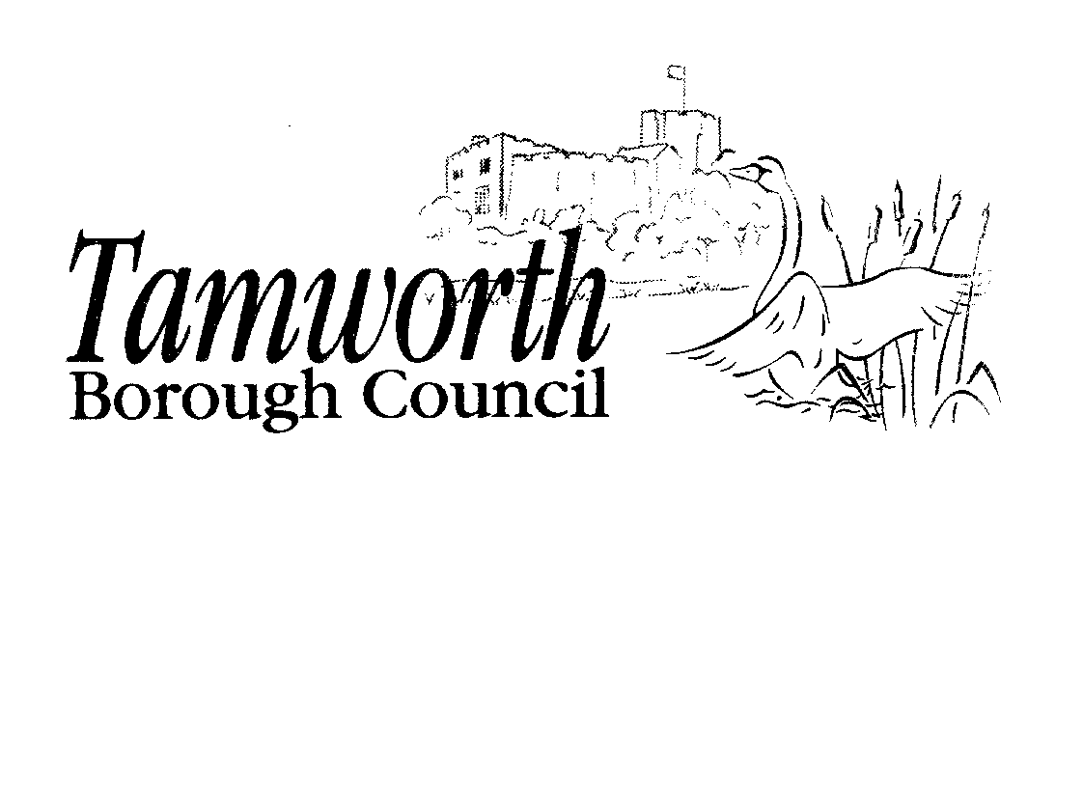
Licensing Act 2003
Club Premises Certificate Summary

Club Details

Name of club in whose name this certificate is granted and relevant postal address of club

Two Gates Working Mens Club, 6 Dosthill Road, Two Gates, Tamworth, Staffordshire, 877 1HU

Telephone - 01827 289645

If different from above, the postal address of club premises to which this certificate relates, if any, or if none, ordnance survey map reference or description

Two Gates Working Mens Club, 6 Dosthill Road, Two Gates, Tamworth, Staffordshire, 877 1HU

Telephone - 01827 289645

Where the club premises certificate is time limited the dates

This club premises certificate is not time limited

Qualifying club activities authorised by the certificate

Provision of Entertainment
A - Plays
B – Films
C – Indoor Sporting Events
E – Live Music
F – Recorded Music
G – Performance of Dance

Provision of Entertainment Facilities

J - Dancing

Supply of Alcohol for Members & Guests

L - Supply of Alcohol

The times the certificate authorises the carrying out of qualifying club activities

Provision of Entertainment
C Indoor Sporting Events
Monday to Sunday
11:00 to 01:00 hours
The times the certificate authorises the carrying out of qualifying club activities

Provision of Entertainment
B Films

Monday to Sunday
11:00 to 01:00
The times the certificate authorises the carrying out of qualifying club activities

Provision of Entertainment
A Plays
Monday to Friday Saturday and Sunday
12:00 to 22:00 hours
12:00 to 20:00 hours
The times the certificate authorises the carrying out of qualifying club activities

Provision of Entertainment

F Recorded Music
Monday to Sunday
11:00 to 01:00 hours
The times the certificate authorises the carrying out of qualifying club activities

Provision of Entertainment

E Live Music
Monday to Sunday
11:00 to 01:00 hours
The times the certificate authorises the carrying out of qualifying club activities
-
Provision of Entertainment Facilities
J Dancing

Monday to Sunday
11:00 to 01:00 hours
The times the certificate authorises the carrying out of qualifying club activities
Supply of Alcohol for Members & Guests L Supply of Alcohol
Monday to Sunday
10:00 to 01:00 hours
Non Standard Timings

Good Friday
12:00 to 22:30 hours
Christmas Day
The hours fixed by or under the rules of the club in accordance with the following conditions:
- the hours fixed shall not be longer than 6½ hours and shall not begin earlier than 12 noon nor end later than 22:30 hours;
- there shall be a break in the afternoon of not less than 2 hours which shall include the hours from 15:00 to 17:00; and
- there shall not be more than 3½ hours after 17:00.
New Year's Eve New Year's Eve
10:00 to 01:00 hours
From the end of permitted hours on New Year's Eve to the start of permitted hours on the following day
The times the certificate authorises the carrying out of qualifying club activities

Provision of Entertainment

G Performances of Dance
Monday to Sunday
11:00 to 01:00 hours
The opening hours of the club
Hours Premises _are Open to the Public
-
--
0 Hours Premises are Open to the Public
Monday to Sunday
10:00 to 01:45 hours
Non Standard Timings

Good Friday Christmas Day
12:00 to 23:15 hours
45 minutes after the final time for any of the licensable activities included in this licence

Where the certificate authorises supplies of alcohol whether these are on and / or off supplies
For consumption on and off the premises

State whether access to the club premises by children is restricted or prohibited

Restricted in accordance with the provisions of the Licensing Act 2003

