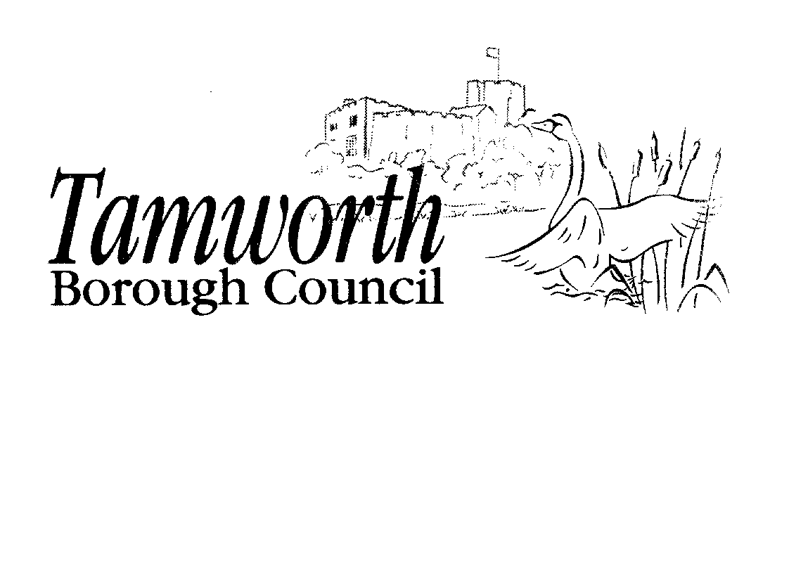
Licensing Act 2003
Club Premises Certificate Summary

Club Details

Name of club in whose name this certificate is granted and relevant postal address of club

Tamworth & District Indoor Bowls Club Ltd
Eagle Drive, Amington, Tamworth, Staffordshire, B77 4EG
Telephone - 01827 51702

If different from above, the postal address of club premises to which this certificate relates, if any, or if none, ordnance survey map reference or description

Tamworth & District Indoor Bowls Club Ltd
Eagle Drive, Amington, Tamworth, Staffordshire, B77 4EG
Telephone - 01827 51702

Where the club premises certificate is time limited the dates

This club premises certificate is not time limited

Qualifying club activities authorised by the certificate

Provision of Entertainment

C - Indoor Sporting Events
Supply of Alcohol for Members & Guests

L - Supply of Alcohol

The times the certificate authorises the carrying out of qualifying club activities

Provision of Entertainment

C Indoor Sporting Events  Monday to Sunday | No restriction

The times the certificate authorises the carrying out of qualifying club activities

Supply of Alcohol for Members & Guests

L Supply of Alcohol  Monday to Saturday  Sunday  Good Friday  Christmas Day  New Year's Eve (except Sunday)  New Year's Eve (Sunday)  New Year's Eve | 10:00 - 23:00 hours  12:00 - 22:30 hours  12:00 - 22:30 hours  The hours fixed by or under the rules of the club in accordance with the following conditions:  1) the hours fixed shall not be longer than 6½ hours and shall not begin earlier than 12 noon nor end later than 22:30 hours;  2) there shall be a break in the afternoon of not less than 2 hours which shall include the hours from 15:00 to 17:00; and  3) there shall not be more than 3½ hours after 17:00.  10:00 - 23:00 hours  12:00 - 22:30 hours  From the end of permitted hours on New Year's Eve to the start of permitted hours on the following day (which would be 10:00 hours if New Year's Day falls on a weekday, or 12:00 hours if a Sunday)

The opening hours of the club

Hours Premises are Open to the Public

O Hours Premises are Open to the Public

Not applicable

Where the certificate authorises supplies of alcohol whether these are on and / or off supplies
For consumption on the premises
and
For consumption off the premises

