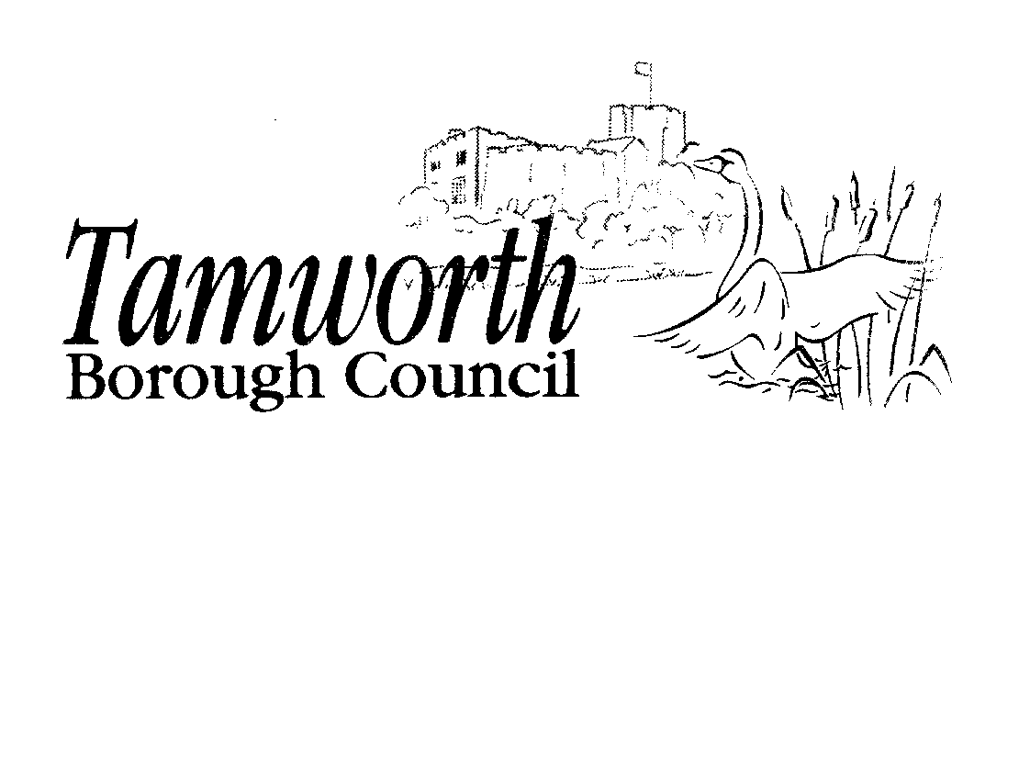

LICENSING ACT 2003
Club premises certificate summary

Dosthill Old Boys Social Club

Club Details

Name of club in whose name the certificate is granted and relevant registered postal address of club

Dosthill Old Boys Social Club, Cadogan Road, Dosthill,

Post Town Tamworth | Post Code B77 1PQ
Telephone number 01827 280850

If different from the above the postal address or club premises to which the certificate relates, or if none, ordnance survey map reference or description

Dosthill Old Boys Social Club, Cadogan Road, Dosthill,

Post Town Tamworth | Post Code B77 1PQ
Telephone number 01827 280350

Where the club premises certificate is time limited the dates

This licence is not time limited

Qualifying club activities authorised by the certificate

Plays
Live Music
Recorded Music
Performances of Dance
The supply of alcohol by or on behalf of a club to, or to the order of, a member of the club
The sale by retail of alcohol by or on behalf of a club to a guest of a member of the club for the consumption on the premises where the sale takes place

The times the certificate authorises the carrying out of qualifying club activities

Plays
Indoors
 | From | To
Sunday
Monday
Tuesday
Wednesday
Thursday | 17:00 | 00:00
Friday | 17:00 | 00:00
Saturday | 17:00 | 00:00

The times the certificate authorises the carrying out of qualifying club activities

Live Music
Indoors
 | From | To
Sunday | 17:00 | 22:00
Monday | 17:00 | 23:00
Tuesday | 17:00 | 23:00
Wednesday | 17:00 | 23:00
Thursday | 17:00 | 23:00
Friday | 17:00 | 01:00
Saturday | 17:00 | 01:00
Non Standard Timings

Christmas Eve 12:00 to 00:00 hours
Boxing Day 12:00 to 00:00 hours

The times the certificate authorises the carrying out of qualifying club activities

Recorded Music
Indoors and Outdoors
 | From | To
Sunday | 12:00 | 23:00
Monday | 10:00 | 00:00
Tuesday | 10:00 | 00:00
Wednesday | 10:00 | 00:00
Thursday | 10:00 | 00:00
Friday | 10:00 | 01:00
Saturday | 10:00 | 01:00
See condition 7 of Annex 2 of the club premises certificate for restriction on hours when this licensable activity takes place outdoors.

The times the certificate authorises the carrying out of qualifying club activities

Performances of Dance
Indoors and Outdoors
 | From | To
Sunday | 12:00 | 23:00
Monday
Tuesday
Wednesday
Thursday
Friday | 12:00 | 00:00
Saturday | 12:00 | 00:00

The times the certificate authorises the carrying out of qualifying club activities

The supply of alcohol by or on behalf of a club to, or to the order of, a member of the club
The sale by retail of alcohol by or on behalf of a club to a guest of a member of the club for the consumption on the premises where the sale takes place

.
 | From | To
Sunday | 12:00 | 23:00
Monday | 10:00 | 00:00
Tuesday | 10:00 | 00:00
Wednesday | 10:00 | 00:00
Thursday | 10:00 | 00:00
Friday | 10:00 | 01:00
Saturday | 10:00 | 01:00
Non Standard Timings

Good Friday | 1200 - 22:30
Christmas Day | The hours fixed by or under the rules of the club in accordance with the following conditions:  (1) The hours fixed shall not be longer than 6 1/2 hours and shall not begin earlier than 12 noon nor end later than 22:30 hours;  2) There shall be a break in the afternoon of not less than 2 hours which shall include the hours from 15:00 to 17:00; and  3) There shall not be more than 3 1/2 hours after 17:00.
New Year's Eve (except Sunday) | 10:00 - 23:00 hours
New Year's Eve (Sunday) | 12:00 - 22:30 hours
New Year's Eve | From the end of permitted hours on New Year's Eve to the start of permitted hours on the following day (which would be 10:00 hours if New Year's Day falls on a weekday, or 12:00 hours if a Sunday).

The opening hours of the club
Not applicable.

Where the certificate authorises supplies of alcohol whether these are on and/or off supplies

On and off supplies.

State whether access to the premises by children is restricted or prohibited

Access is restricted

