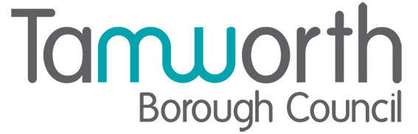

Council Tenant Factsheet: right to manage

Council tenants have a legal right to manage their housing services through the formation of a Tenant Management Organisation (TMO). This allows residents to take control of day-to-day management tasks while the council retains ownership of the properties.

Who can set up a TMO?
- The group must represent at least 25 council homes (may vary by council).
- Tenants must go through a development stage including training and competence assessment.
- A ballot must be held, and a majority of tenants must vote in favour.
- The TMO must enter into a modular management agreement with the council.

What can a TMO Manage?
- Day-to-day repairs and maintenance.
- Cleaning and caretaking.
- Rent collection and arrears.
- Tenancy management and neighbour disputes.
- Grounds maintenance.

How to form a TMO?
- Form a tenant group and explore interest in managing services.
- Undertake training and develop a business case.
- Pass a competence assessment conducted by the council or an approved body.
- Hold a formal ballot of all affected tenants.
- Sign a management agreement with the council and begin operations.

Your rights and support
- Council tenants retain all tenancy rights under a TMO. The landlord remains the council, and tenants can access support from national bodies, local housing teams, and government guidance.

Where to get more information
- National Federation of TMOs: https://www.nftmo.com
- Government guidance: https://www.gov.uk/government/publications/right-to-manage-statutory-guidance-part-1
- Local council housing engagement teams

 Need help or advice?
- Contact Tamworth Borough Council’s Estate Management Team on 01827 709514 or email: estatemanagementteam@tamworth.gov.uk. Monday to Thursday 8.45am - 5.10pm and Friday 8.45am - 5.05pm. Phone lines are closed on national bank holidays.
- If you need this factsheet in another language, in large print, in audio format, or in any other accessible format, please contact us. We’ll be happy to provide the information in a way that works best for you.
- Repairs freephone: 0800 183 0044. This number is available 24/7, including for emergency and out-of-hours repairs.

Need to make a complaint?
To make a complaint you can:
- Complete a Comments, Compliments and Complaints form via our MyTamworth customer portal.
- Telephone 01827 709709.
- Email complaints@tamworth.gov.uk
- Write to us at Marmion House, Lichfield Street, Tamworth, Staffordshire, B79 7BZ.
- Visit our reception at Marmion House (10am – 2pm Monday, Tuesday, Wednesday, and Friday. 2pm – 6pm Thursday)
- Ask any member of staff to assist.

We accept complaints from third parties who have the customers permission to act on their behalf in making the complaint. (This can be from any person, for example a relative, friend, councillor, MP)

