Tamworth Flood Risk Management Scheme
Ground Investigation works
December 2025

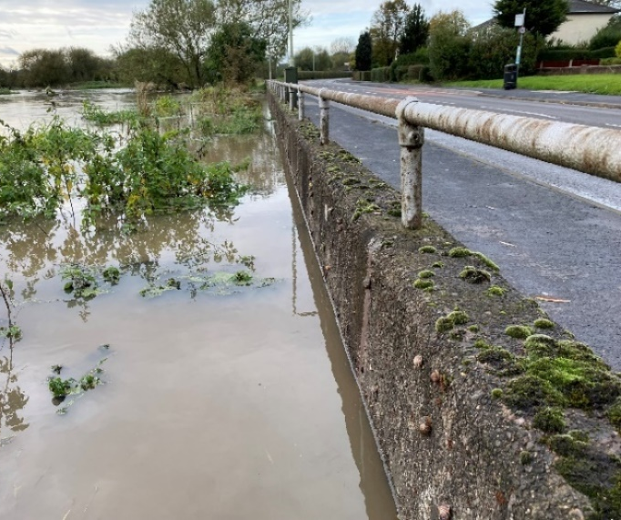
Tamworth has a long history of flooding and 2024 and 2025 saw very high river levels which reminds us of the increasing flood risk that the River Tame and River Anker pose to the town.
We are in very early stages of developing a project to improve the flood defences in Tamworth and initial ground investigation works are now required to inform the cost and design of the scheme.

Ground Investigation Works
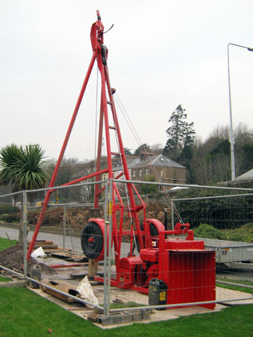
Ground investigations involve taking soil samples from boreholes which may be hand-dug or drilled using a small mobile rig to extract a core sample. This work will only require us to be on site for a few days at each hole, including mobilisation, carrying out the works, demobilisation, and reinstatement. We will keep any disruption to a minimum and will fully reinstate any disturbance caused during the process.
Figure 1. Example of existing flood wall
- Ground investigation work is planned to start in January 2026 and take place over 12 weeks
- There are approximately 86 boreholes and hand dug pits along the catchment
- We will be working in multiple locations at any given time.
- Works will require some traffic management on Lichfield Road. Footpaths on top of flood defences will be closed while we are doing the works.
- The works will create some noise but are generally away from homes. In some circumstances there is closer proximity to properties, but we will be in contact with landowners and immediate neighbours.
Figure 2. Example of a ground investigation rig

Ground Investigation Works – Proposed Borehole Locations
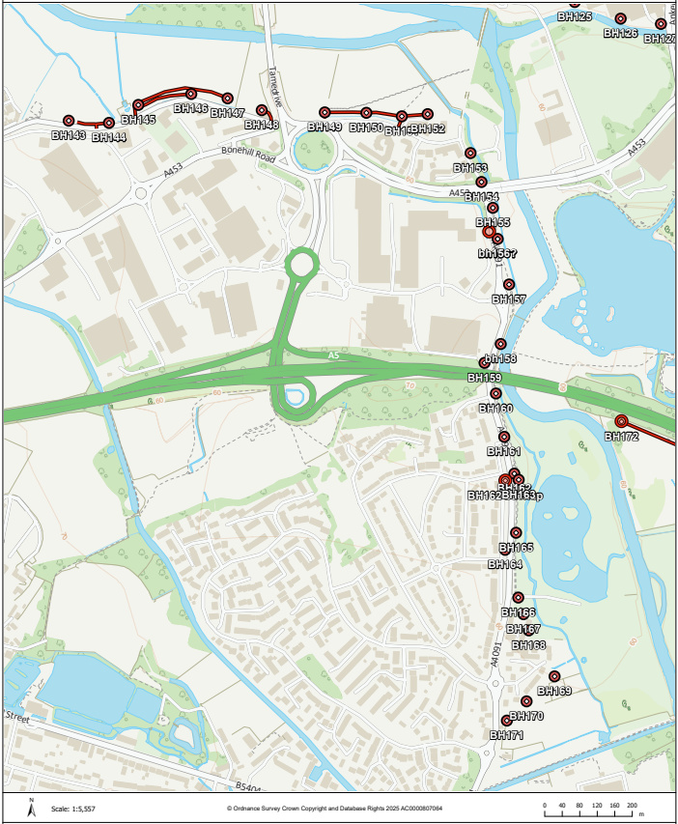
Figure 3. Proposed Borehole locations - Fazeley Road and Bonehill Road areas
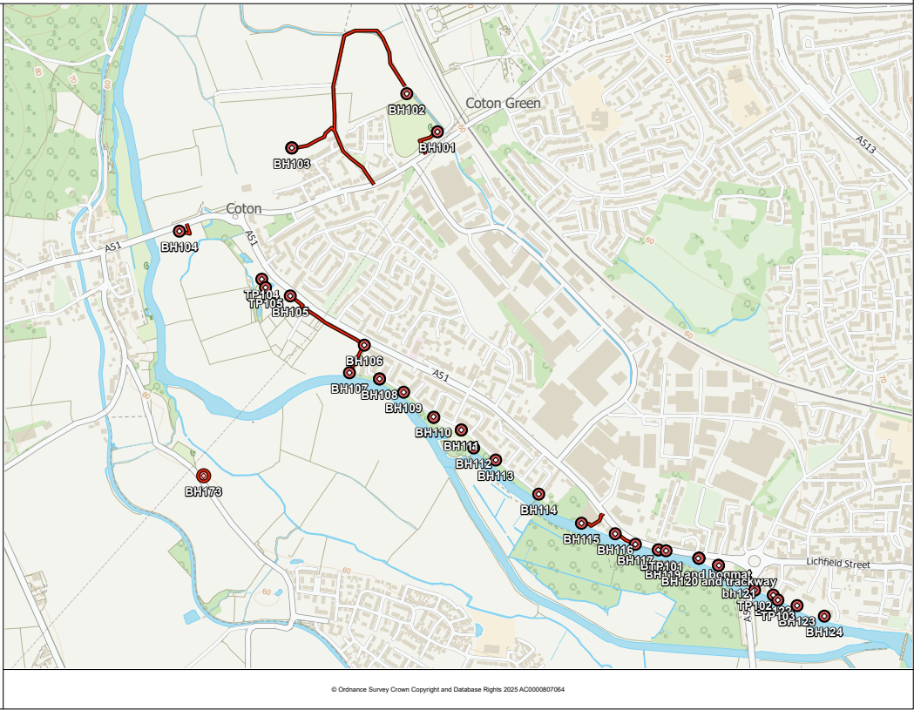
Figure 4. Proposed Borehole locations - Lichfield Road and Coton
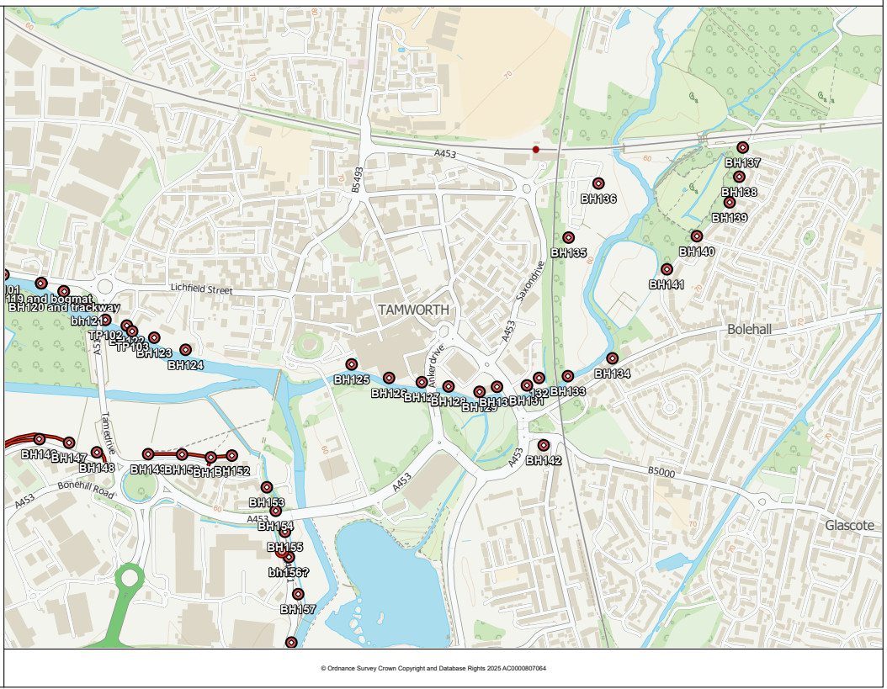
Figure 5. Proposed Borehole Locations – Central area, Moor Lane and Station Fields
Further information
The works are being undertaken by Jackson Civil Engineering, who have a public liaison officer available on the ground to answer specific questions about these ground investigation work.
Simon Campbell – Public Laison Officer 07974 416461 SCampbell@jackson-civils.co.uk
The Environment Agency can also be contacted about the flood risk management scheme at TamworthFRMS@environment-agency.gov.uk

