

Notice of vacancy in the office of Councillor for Mercian Ward

I must give notice, under Section 87(2) of the Local Government Act 1972, that a vacancy exists in the office of Borough Councillor for the Mercian Ward of Tamworth Borough Council.

The vacancy has arisen due to the resignation of Cllr Richard Kingstone.

In accordance with Section 89(3) of the Local Government Act 1972, where the vacancy occurs within six months before the day on which the councillor whose office is vacant would regularly have retired, an election shall not be held under Section 89(1) of the Act.

The vacancy will be filled at the next ordinary election of Councillors on Thursday 7 May 2026.

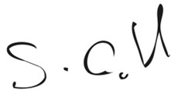
Stephen Gabriel
Proper Officer

Dated: Tuesday 18 November 2025

